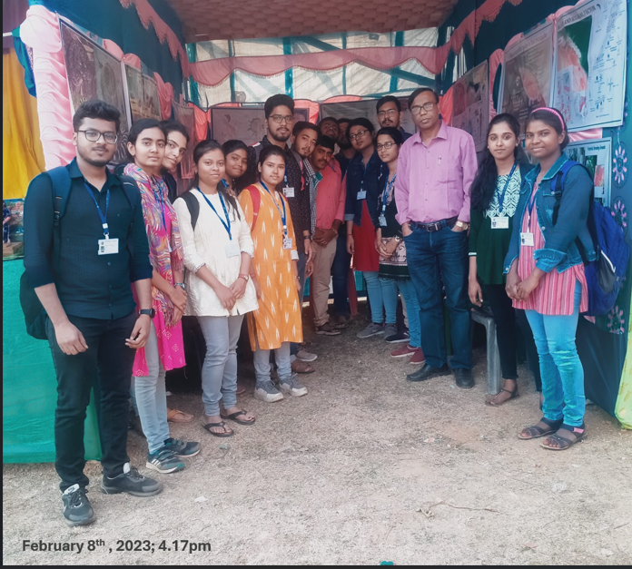
Fig. xx Fish-capturing techniques and Pearl culture

